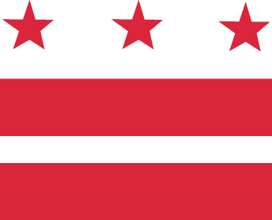

D.C. MEDICAL CARE ADVISORY COMMITTEE

Wednesday, August 30, 2017, 5:30-7:30 pm
District of Columbia Department of Health Care Finance (DHCF)

441 4th Street, NW, 10th Floor North, Conference Room #1028, Washington, DC 20001
Call-in: 1-877-709-6519, code 1819767

AGENDA

- Approval of minutes
- Senior Deputy Director/Medicaid Director Report
  - Announcement: new MCAC membership
  - Discussion: MCO membership on MCAC
  - Request: NAMD fall meeting, session with Medicaid beneficiaries
  - Discussion: ACA and CHIP
- Subcommittees
  - Report outs (from each subcommittee)
    - Access
    - Enrollment/Eligibility
    - Health System Re-Design
    - Long Term Services and Supports
- New Business
- Opportunity for Public Comment
- Announcements
  - September 5-6, My Health GPS Two Day Workshop (contact Joe Weissfeld for details at joe.weissfeld@dc.gov)
  - September 22, Borderline Personality Disorder Training, SOME, Inc. and DCBHA (contact Mark LeVota for details at mark.levota@dcbehavioralhealth.org)
- Adjourn

