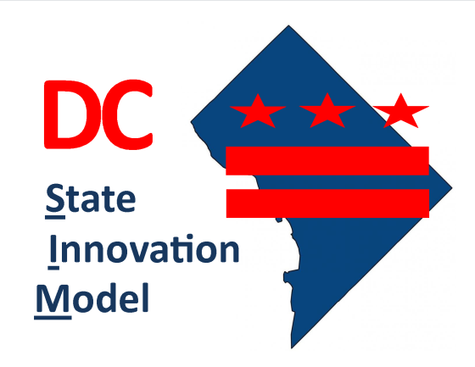
SIM ADVISORY COMMITTEE MEETING
Wednesday, January 13, 2016
441 4th St NW – Room 1028
2:00 pm – 4:00 pm

AGENDA

- Introductions

- Introduce Navigant Consulting

- Brief Overview of Driver Diagram

- Accountable Health Communities Model Grant Program Opportunity

- Discussion on Work Group Activities
  - Care Delivery Model
  - Community Linkages
  - Health Information Exchange
  - Payment Models
  - Quality

- Stakeholder Engagement Activity

- Wrap Up

