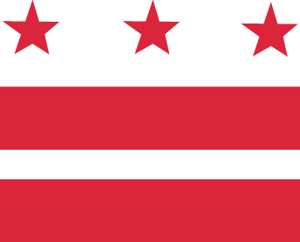

D.C. MEDICAL CARE ADVISORY COMMITTEE

Wednesday, May 31, 2017, 5:30-7:30 pm
District of Columbia Department of Health Care Finance (DHCF)

441 4th Street, NW, 10th Floor North, Conference Room #1028, Washington, DC 20001
Call-in: 1-877-709-6519, code 1819767

AGENDA

- Approval of minutes
- Senior Deputy Director/Medicaid Director Report
  - Update: American Health Care Act of 2017 (H.R. 1628)
  - Discussion: DOH’s Health Systems Plan 2017
- Subcommittees
  - Vote on new Access chair
  - Discuss proposals
  - Report outs (from each subcommittee)
- New Business
  - Discussion: Legislation as an enabler of good health in communities
- Opportunity for Public Comment
- Announcements
- Adjourn

