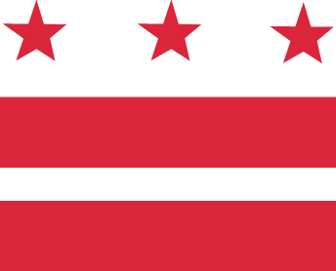

D.C. MEDICAL CARE ADVISORY COMMITTEE
2019 Budget Briefing

Wednesday, March 28, 2018, 5:30-7:30 pm
District of Columbia Department of Health Care Finance (DHCF)
441 4th Street, NW, 10th Floor North, Conference Room #1028, Washington, DC 20001
Call-in: 1-877-709-6519, code 1819767

SPECIAL AGENDA

- Introductions
- DHCF Budget Briefing (with Director Wayne Turnage and staff)
- Question and Answer

