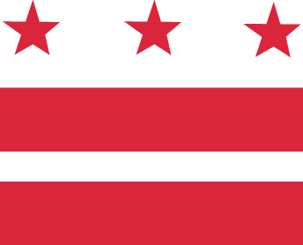

D.C. MEDICAL CARE ADVISORY COMMITTEE

Wednesday, February 28, 2017, 5:30-7:30 pm
District of Columbia Department of Health Care Finance (DHCF)
441 4th Street, NW, 10th Floor North, Conference Room #1028, Washington, DC 20001
Call-in: 1-877-709-6519, code 1819767

AGENDA

- Approval of minutes
  - December 2017
- Senior Deputy Director/Medicaid Director Report
- Subcommittees
  - Patient and Family Advisory Committee (PFAC) update
  - Report outs (from each subcommittee)
    - Access
    - Enrollment/Eligibility
    - Health System Re-Design
    - Long Term Services and Supports
- New Business
  - MCAC Member Presentation
- Opportunity for Public Comment
- Announcements
  - DHCF Budget Hearing
- Adjourn

