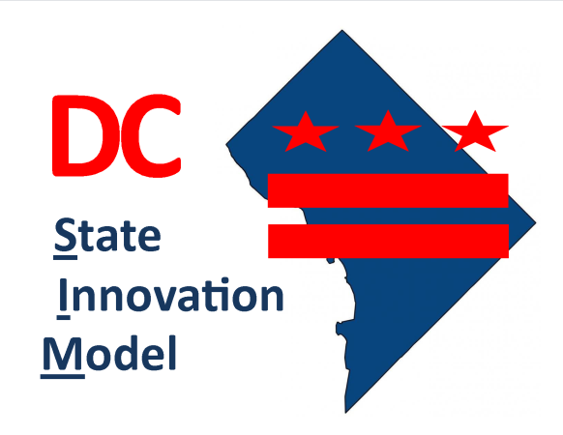 | State Innovation Model  Advisory Committee  Meeting  Wednesday, October 14, 2015  3:00 – 5:00 PM  Location:  One Judiciary Square  441 4th Street, NW, Room 1028  Washington, DC 20001
Committee Members (Invitees):

Christian Barrera (Office of the Deputy Mayor for Health and Human Services); Yvette Alexander (City Councilmember, Ward 7); Rayna Smith, Esq (Committee on Health and Human Services); Claudia Schlosberg (Department of Health Care Finance); Lisa Fitzpatrick, MD (Department of Health Care Finance); LaQuandra S. Nesbitt, MD (Department of Health); Laura Zeilinger (Department of Human Services); Stephen Taylor (Department of Insurance, Securities and Banking); Tanya Royster, MD (Department of Behavioral Health); Jullette Saussy, MD (Fire and EMS Department); Mara Krause Donahue (Medicaid Beneficiary Representative); Amy Freeman (Providence Hospital); Mark Weissman, MD (Children’s National Health System); Jonathan Blum, MD (CareFirst); Karen Dale, RN, MSN, CS (AmeriHealth); Maria Gomez, RN, MPH (Mary’s Center); Angela Diop, ND (Unity Healthcare); Reverend Frank Tucker (First People Church); Reverend Christine Wiley (Convenant Church); Christy Respress (Pathways to Housing); Christopher King, PhD (Georgetown University School of Nursing and Health Studies), Jacqueline Bowens (District of Columbia Primary Care Association), Laura Nuss (Department on Disability Services), Richard Bebout, (Green Door)

DHCF/HCRIA Staff: Shelly Ten Napel, DaShawn Groves, Dena Hasan, Joe Weissfeld
  - Agenda
- Introductions |  | Entire Committee
- National Payment and Delivery System Reform Landscape  - What payment models are being considered as value-based purchasing options in both the public and private sector?  - What have other SIM health care delivery and payment models looked like in other states?  - How have other states succeeded in the operationalization of payment reforms?  - How was "readiness" determined by states as they used new models or adopted payment reforms? |  | Michael Bailit, MBA  President, Bailit Health
- District’s Vision for Care Delivery and Payment Model Reform  - What is the District’s vision for delivery system and payment reform? |  | Dr. Nesbitt  Director, Department of Health
- Next Steps
  - Upcoming Meeting Dates
(January 13th, March 9th, May 11th, July 13th)
- Adjournment

