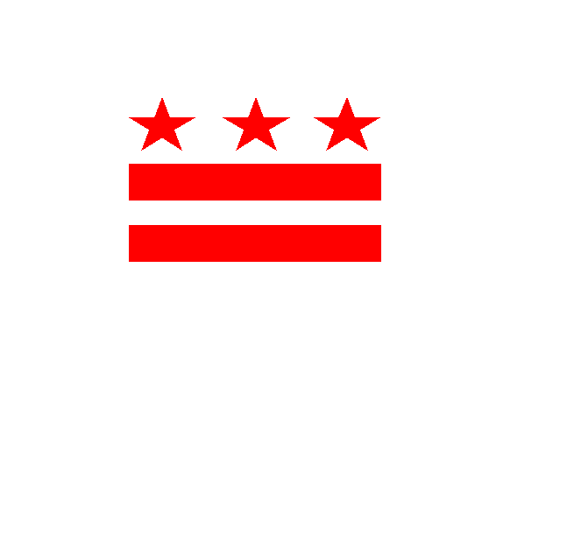
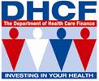
Come and Join the Department of Health Care Finance Division of Managed Care
For our 1st Annual FQHC Provider Workshop Entitled

“Working Together to Make the Connections”
Friday, February 10, 2017
10:00 a.m. – 3:00 p.m.
Old City Council Chambers (The Main Lobby)
441 – 4th Street, N.W., Washington, D.C. 20001

Who should attend?
Providers, Billers, Office Managers, Claims Adjusters
Appeals Managers

To register, please call Felecia Vida Stovall (202) 724-2315 or via
email felecia.stovall@dc.gov by Wednesday, February 8, 2017.

Hope to see you there!!

- Parking is limited! We suggest the Metro (Red Line to Judiciary Square. Take the 4th Street Exit)

