GOVERNMENT OF THE DISTRICT OF COLUMBIA

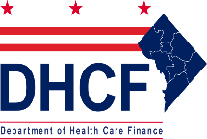
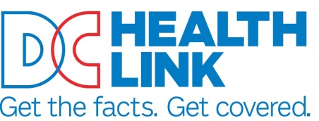

<Date of Notice> Account ID:

<Primary First Name> <Primary Last Name>
<Primary Street Address 1>
<Primary Apt/Suite>
<Primary City>, <Primary State> <Primary Zip>

Subject: Termination Notice Sent due to System Error

Dear <Primary First Name> <Primary Last Name>:

On [Date of 310-Notice Trigger], you were sent a notice of termination in error due to a system issue. In compliance with the COVID-19 Medicaid Continuous Eligibility Requirement guidelines, no action has been taken to terminate Medical coverage for you or anyone in your household.

The following persons remain eligible for Medicaid:
<Medicaid 1 First Name><Medicaid 1 Last Name>: Medicaid ID# <Medicaid 1 Medicaid ID>
[IF Person N field populated]<Medicaid N First Name><Medicaid N Last Name>: <Medicaid N Medicaid ID>

We have researched the issue, determined the root cause, and identified a resolution. If you have any questions or concerns about your medical coverage, please feel free to contact the Economic Security Administration at 202-727-5355 or by visiting any of the Service Center locations. You may also log into your District Direct account to get updated information.

Your Secure User Account

Important information is stored in your account on our DC websites. If you don’t have an account already and are seeking Medicaid, DC Healthcare Alliance, or Immigrant Children Program coverage, you can create one by going to districtdirect.dc.gov. Medicaid, DC Healthcare Alliance, or Immigrant Children Program customers can get help with logging in or creating an account by calling the DHS Call Center at (202) 727- 5355 / TTY 711.

If you don’t have an account already and are seeking Individual & Family health insurance coverage, you can create one by going to www.DCHealthLink.com. Individual & Family health insurance customers can get help with logging in or creating an account by calling DC Health Link Customer Service toll-free at (855) 532-5465 / TTY 711

If You Think We Made a Mistake

If you disagree with any determination about the amount or type of health care coverage benefits you or any of the other person in your household was found eligible for, you have the right to appeal the determination(s). You may request an appeal by phone, in person, online, and by mail. You have 90 days from the postmark of this notice to file an appeal. D.C. Official Code §4-210.09, 42 C.F.R. §431.221, and 45 C.F.R. §155.520.

