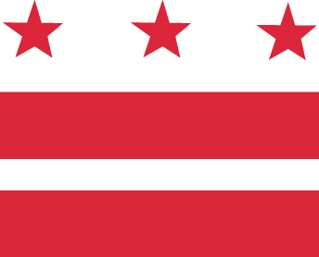

D.C. MEDICAL CARE ADVISORY COMMITTEE (MCAC)
Sub-Committee Proposal Form

All MCAC sub-committee proposals must be submitted for consideration by the MCAC using this form. Proposals must come from the respective sub-committee chair to MCAC Liaison Trina Dutta (trina.dutta@dc.gov) at least two weeks in advance of the next scheduled MCAC meeting.

- Proposal Title: Ombudsman Phone Number Required on all Beneficiary ID cards

- Submitting Sub-Committee (choose one) (Other: PFAC)
☐Long Term Services and Supports
☐Health Care Re-Design
☐Enrollment & Eligibility
☐Access

- Abstract
In 100 words or less, explain the proposal being submitted for MCAC’s consideration.

MCAC hereby proposes to require all Beneficiary ID Cards for Medicaid to be printed with the DC Ombudsman's Hotline on all new or re-issued Medicaid/MCO membership cards.
MCOs should voluntarily comply immediately until an official Contract Mod is processed; but as part of the Contract Mod, All Beneficiary Cards given out by MCOs must have "Prior Review and Approval of Content and Format" by DHCF for DC Medicaid to check for Format and Inclusion of required ID Card information. No changes in ID Cards format/content will be allowed without "Prior Content Approval by DHCF and/or the Ombudsman's office".

- Proposal
In 1000 words or less, explain the problem being addressed and propose a discrete and actionable solution for the MCAC’s consideration. Include any scheduling and/or budget implications, along with risk and mitigation strategies of this proposal.

The PFAC group submits this proposal to require all Beneficiary ID Cards for Medicaid to Print the DC Ombudsman's Telephone Number on Every Medicaid/MCO membership Card. It can be done either by immediate Contract Mod or Regulation, but All New or Re-issued cards must add the Ombudsman's Hotline and/or DHCF numbers for Feedback and Complaints by Beneficiaries.

DHCF should start by requesting MCOs to voluntarily Print the number immediately until an official Contract Mod is processed; but in the immediate Future as part of the Contract Mod, All Beneficiary Cards given out by MCOs must have "Prior Review and Approval of Content and Format" by DHCF for DC Medicaid before being given out to Beneficiaries to check for Format and Inclusion of required ID Card information. No changes in ID Cards format or content will be allowed by MCOs without "Prior Content Approval by DHCF and/or the Ombudsman's office".

- Supporting Documentation
Any supporting documents should be provided as attachments to this proposal, and referenced in the Q4 Proposal above. List these below.
- Current Photo of Back of the Amerigroup Card for Example:
- Click here to enter text.

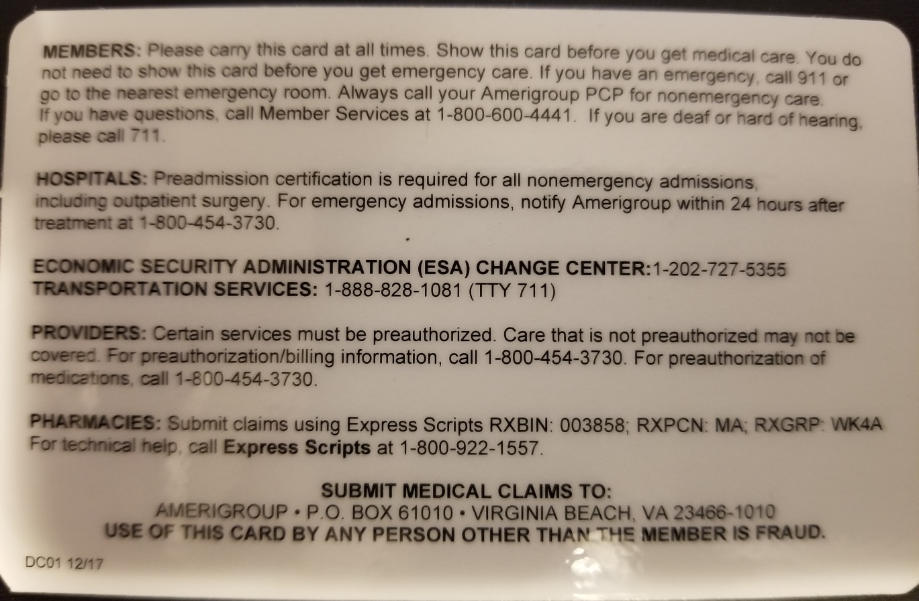

All supporting documents should be provided as attachments to this proposal.

