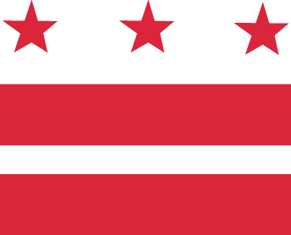

D.C. MEDICAL CARE ADVISORY COMMITTEE
FY 2018 Meeting Schedule

Time: All meetings will occur 5:30 pm to 7:30 pm (unless otherwise indicated)

Location: District of Columbia Department of Health Care Finance (DHCF)
10th Floor North, Conference Room #1028
441 4th Street, NW
Washington, DC 20001
(Judiciary Square Metro stop)

Conference Call-In: 1-877-709-6519, code 1819767

Meeting Dates: October 25, 2017
December 13, 2017
February 28, 2018
April 25, 2018
June 27, 2018
August 29, 2018

Standing Agenda: Approval of minutes
Subcommittee Report(s)
DHCF Director or Senior Deputy Director/Medicaid Director Report
New Business
Opportunity for Public Comment
Announcements
Adjournment

If you have questions, please contact Ms. Carmelita White, Executive Assistant to the Senior Deputy Director/Medicaid Director, at Carmelita.white@dc.gov or 202-698-2023.

To participate in a sub-committee, which is open to the public, please contact the following liaisons: Michael Bolling, Michael.bolling2@dc.gov (Long Term Services and Supports); Kivon Allen, Kivon.allen@dc.gov (Eligibility& Enrollment); Yorick Uzes, Yorick.uzes@dc.gov (Access); and DaShawn Groves, dashawn.groves@dc.gov (Health Care Re-Design)

