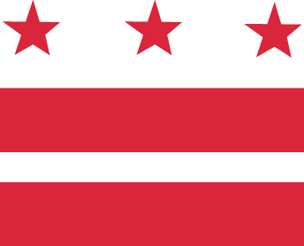

D.C. MEDICAL CARE ADVISORY COMMITTEE

Wednesday, February 15, 2017, 1:00-5:00 pm
District of Columbia Department of Health Care Finance (DHCF)

441 4th Street, NW, 10th Floor North, Conference Room #1028, Washington, DC 20001
Call-in: 1-877-709-6519, code 1819767

AGENDA

1:00-1:05 Approve: Minutes
1:05-1:15 Vote: MCAC Vice-Chair
1:15-2:00 Discuss: MCAC Roles and Responsibilities
2:00-2:15 Review: MCAC Sub-Committees
2:15-2:30 Break
2:30-4:00 Breakout: by Sub-Committees
Goals:
- Define expectations (meeting frequency; decision-making processes; etc.)
- Finalize each sub-committee’s charter
- Develop priorities through October 2017
4:00-4:45 Report Out: Sub-Committees to MCAC Body
4:45 Opportunity for Public Comment
Announcements
5:00 Adjournment

Note that the call-in capacity will not be available during breakout sessions.

