District of Columbia Health Care Association
An affiliate of the American Health Care Association
1220 L Street, NW Suite 100-242
Washington, DC 20005
Phone: 410-798-4925 Fax: 410-798-9260
www.dchca.org

July 14, 2016

Trina Dutta
Special Projects Officer
Department of Health Care Finance
441 4th Street, NW
922a
Washington, DC 20001

RE: Comments on the Proposed MCAC By-laws

Dear Ms. Dutta:

Thank you for the opportunity to comment on the Proposed MCAC By-laws. After review of the draft By-laws, the District of Columbia Health Care Association (DCHCA) offers its support of the draft as written. The By-laws if approved as written will be current and reflective of the role of the MCAC.

We offer our sincere thanks to the DHCF staff and MCAC volunteers that worked on the revision.

Sincerely,

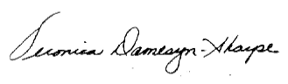

Veronica Damesyn Sharpe
President

cc: DCHCA Board of Directors
Claudia Schlosberg

